Week 4 Plated Main Courses
STANDARD RECIPE

Dish name: Turbot, crab veloute, cannelloni, bloody Mary gel, saffron yoghurt, fennel textures

Photographs of completed dish presentation:
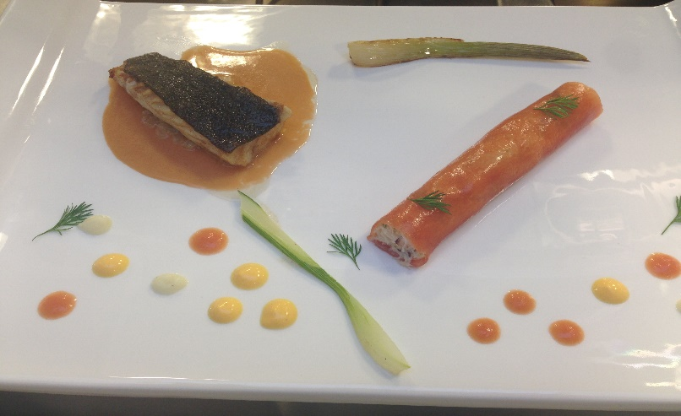

INGREDIENTS | QUANTITY  FOR 4
1-TURBOT
Turbot | 2kg
Filtered sea water | 200mls
Butter
Lemon zest , black pepper
02-CRAB “VELOUTE”
Velvet crabs | 2kg
Chicken stock | 3 liters
Tomatoes | 4
Garlic clove | 1
Tomato diced | 3
Shallot diced | 1
Fennel bulb diced | ½
Xanthan gum | .8gr
Arbequina olive oil | 20 mls
Neutral oil
Mayonnaise | 20 mls
Seasoning
03 CRAB “BLOODY MARY”CANNELONI STUFFING
Crab veloute | 20 mls
Cucumber | 5g
Shallot | 5g
Crab meat | 150g
Celery diced | 10g
04-CANNELLONI SHEET
Tomato juice | 150mls
Grapefruit juice | 50mls
Celery juice | 40 mls
Cork dry gin | 10ml
Agar | 1g
Gellan | 1.6 gr
Gelatine powder | .8gr
05-GRILLED FENNEL
Baby fennel | 4
Salt , lemon zest
Olive oil
06-CONFIT FENNEL AND PUREE
Fennel bulbs | 4
Star Anise | 1
Olive oil
Lemon peel , pepper
07-BLOODY MARY GEL
Tomatoes | 250g
Celery juice | 50ml
Gin | 15 ml
Tabasco , pepper , salt
Lemon zest
Agar agar | 1.2gr per 100g liquid
08-SAFFRRON YOGHURT
Yoghurt | 200mls
White wine vinegar | 25ml
White wine | 75ml
Saffron powder | .3gr
Gelatin leaf | .5
Salt
09-GARNISH
Fennel seed flowers
Fennel loaf
Oregano tops , white borage Blanca

PRODUCTION METHOD
MISE EN PLACE
1.Gather all ingredients
2.wash , peel , rewash all vegetables
3 juice all vegetables
4.Fillet turbot
5.infuse chicken stock with turbot bones
6.Trim fennel

COOKING/PREPARATION
TO MAKE TURBOT
- Fillet the turbot
- Carefully portion the fish in 70g steaks
- Brine the necessary amount in filtered seawater
- Wash the bones under cold water and reserve for veloute
TO MAKE CRAB VELOUTE
- Infuse chicken stock with turbot bones over medium heat for 25 minutes
- Strain and bring chicken/ turbot stock to the boil and remove any impurities that come to the surface
- Put the velvet crab in a food mixer fitted with a k shaped spatula , along with the tomato and garlic and set it to crush the crabs ,slowly until the mix is fully crushed
- Pour in 50 % of the boiling stock and let it mix for another 2 minutes
- Remove the mix from the food mixer and add the rest of stock
- Bring this up to a simmer and let it infuse for an hour
- Using a stick blender, mix it through again and then strain it, this is first base
- In a wide bottomed pot heat some oil over high heat and fry off the tomato , fennel and onion until well softened and then add a 1/3 of the garbure base and start reducing it
- When it starts to thicken add a ladle more of the base and repeat this action until all the veloute base is incorporated and reduced , total volume should be reduced to 400ml or 500ml
- Pass this through a very fine sieve
- This is second crab base
- Allow the second crab base to cool until its luke warm and measure out 250mls into blender cup
- Add .8g of xanthan gum and 20 ml Arbequina olive oil and seasoning if needed
- Blend to create a creamy textured liquid
- Sieve it again and pour into smaller bottle for later use
TO MAKE CRAB FILLING FOR THE BLOODY MARY CANNELLONI
- Mix all ingredients together and season to taste
- Place in piping bag and keep in fridge until ready to use
TO MAKE CANNELLONI SHEET
- Spread a very thin layer of oil on a rectangular tray measuring 30cm by 40cm
- Mix all ingredients together along with a pinch of salt
- In a suitable pot bring to the boil
- When the mix is boiling pour it directly onto the oiled tray and let it sit
- Do not move or disturb the tray as the mix will gel instantly and any movement will ripple the surface
- After 15 minutes the gel will be set and can be refrigerated until needed
- To assemble the cannelloni, slice a strip from the gel measuring 12cm by 16cm and pipe a layer of crab onto it
- Carefully roll it up and keep it covered in the fridge until needed
TO MAKE GRILLED FENNEL
- Trim most of the stalks off the baby fennel and remove the loaf which will be used for garnish
- Blanch fennel in boiling salted water until tender
- Plunge into iced water to stop cooking
- When cool , dry the fennel and grill them
- Add a few drops of olive oil and heat through in hot oven to warm through
TO MAKE CONFIT FENNEL AND PUREE
- Heat olive oil in small pot for 2 minutes along with star anise, lemon peel and some peppercorns .set aside.
- Slice the fennel into fine brunoise and place in the oil
- Reserve the trimmings for the puree
- Confit the fennel dice on low heat until tender but retaining a bit of bite , then set aside
- Dress the fennel trimmings like a salad by sprinkling with olive oil , a squeeze of lemon and seasoning , put in a vacuum pack bag and cook in steam oven until completely soft
- Add fennel trimming to blender and blend until smooth
- Push puree through a sieve and store in a squeeze bottle
TO MAKE BLOODY MARY GEL
- Roast tomatoes in oven set to 200C for 10 to 15 minutes until soft
- Place in blender, blend , sieve and season to make a coulis
- Add the celery juice , gin and other seasoning and then measure out the mix
- Add 1.2g of agar agar to every 100gr of weight and bring the mix to the boil
- Pour this into a container and when its set push it through a sieve and whisk into a gel
- Place in squeeze bottle until needed
TO MAKE SAFFRON YOGHURT
- Soak the gelatin in cold water
- In a small pot mix the white wine vinegar , wine and saffron
- Bring this to the boil and reduce by half
- Add the gelatin and dissolve it in the liquid
- Let the mix cool before adding the yoghurt and seasoning to taste
- Place in a squeeze bottle until needed

PRESENTATION AND SERVICE
- Place the turbot skin side down in a non-stick pan and start to slowly fry it , adding a knob of butter and basting the fish until it starts to cook
- Season flesh side at last moment before flipping it over
- Pour some crab veloute onto the plate and place strained confit fennel in the middle
- On a separate plate to the side of the main dish ,place the cannelloni and the grilled fennel
- Finish this by dotting the sauces around the cannelloni and dressing the plate with the herbs
- Finally place the turbot on the confit fennel and serve

