Week 2 Amuse Bouche 2-1-2015

STANDARD RECIPE

Dish name:
Mushroom jelly with mushroom cream
Lamb jelly with cucumber
Szechwan Broth

Photographs of completed dish presentation:
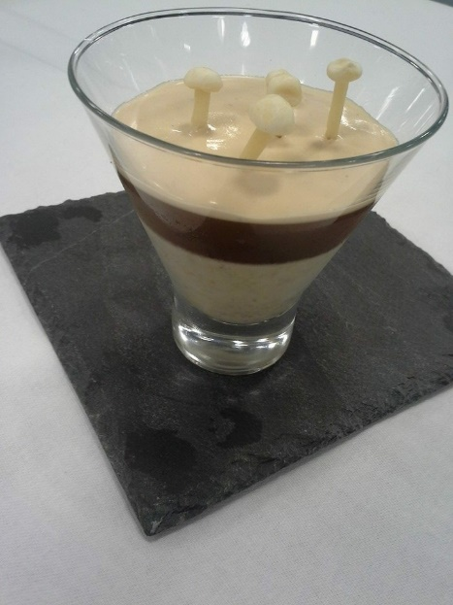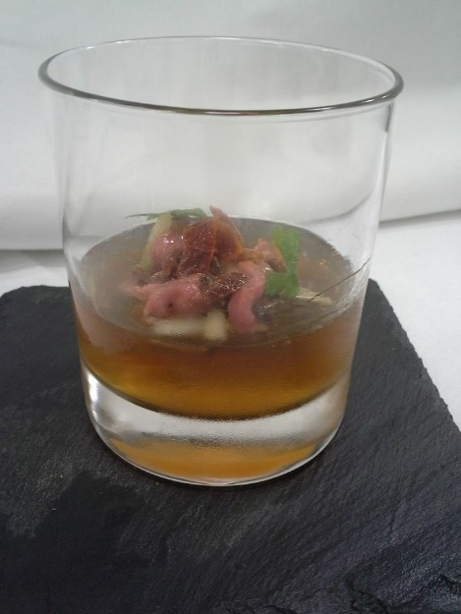

INGREDIENTS | QUANTITY  FOR 4
LAMB JELLY WITH CUCUMBER
Lamb Stock | 1.6 kg
Sprig rosemary | 1
Sprig of Tarragon | 1/2
Sprigs of coriander | 4
Sprigs of flat leaf parsley | 4
Leaves of gelatin | 7 (cut with scissors)
FOR LAMB SALAD
Lamb tenderloin | 200g
Cucumber, peeled , deseeded, and cut in small bayonets | 65g
Oven dried tomato halves , cut into strips , | 18
Mustard vinaigrette
Small chervil leaves | 12
Mustard Vinaigrette
White wine vinegar | 40g
Dijon or wholegrain mustard | 40g
Groundnut or grape seed oil | 120g
MUSHROOM JELLY WITH MUSHROOM CREAM
To fortify and clarify the mushroom stock
Peeled and finely sliced shallot | 25g
Dry martini | 95g
Mushroom stock | 500g
Mushroom ketchup | 1 & ½ tsp
Leaves of gelatin , softened in cold water | 12g
FOR THE MUSHROOM PUREE (LAYER 1)
unsalted butter | 30g
Peeled and finely sliced onion | 50g
Cleaned and finely sliced leek ,white part only | 50g
Finely sliced button mushroom | 200g
Dry white vermouth | 15g
Vegetable stock | 150g
Double cream | 15g
Mushroom ketchup | ½ teaspoon
salt
Leaves of gelatin, softened in cold water. | 6g
FOR THE MUSHROOM JELLY (layer 2)
The Clarified stock
Leaves of gelatin , softened in cold tap water | 6g
FOR THE MADERIA AND SHERRY CREAM (layer 3)
Dry madeira | 100g
Oloroso sherry | 100g
Double cream | 100g
Enoki mushroom to garnish
SZECHUAN BROTH (consommé)
Chicken wings | 1kg
Pork ribs (cut into individual ribs | 1.5kg
Large onion | 1
Star anise | 3
Shaoxing wine or Manzanilla sherry | 180g
Peeled and finely sliced fresh root ginger | 75g
Szechuan peppercorns | 5g
Cinnamon stick | 1
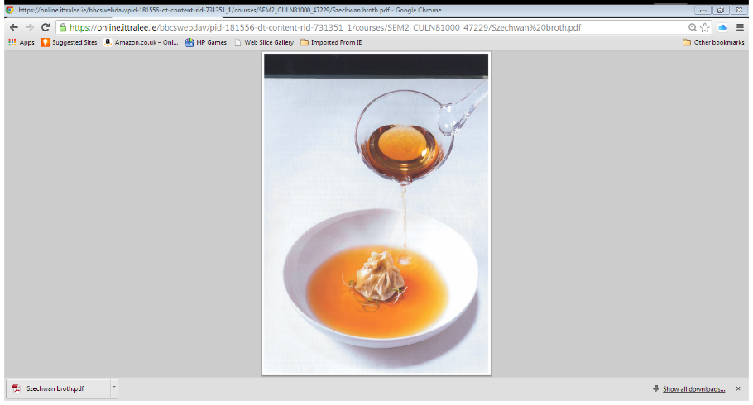

PRODUCTION METHOD
MISE EN PLACE
1. Gather all equipment
2.Weigh out ingredients
3 Wash re was and prepare all vegetable
4.filter the stock by ice filtration
5.Szechuan broth to be prepared in advance in order for ice filtration of broth
6.Pressure cooker
COOKING/PREPARATION
7.For lamb jelly ,filter lamb stock by ice filtration
8.Pour clarified stock into clean saucepan ,boil and reduce to half over high heat ,leaving 500g of stock
9. Infuse the stock with herbs for 12 hours, then strain and season with salt.
10. Soften the gelatin in cold water, squeeze dry and add to 100g of lamb stock.
11. Heat just enough to dissolve the gelatin and whisk the mixture into the rest of the stock.
12. Divide the finished stock into 6 medium bowls and refrigerate for 2 hours.
PRESENTATION AND SERVICE
13 When ready to serve, season lamb tenderloin with salt and sear in very hot, oiled pan on all sides, allow the meat to rest for 10 minutes, then cut into small cubes.
14.Gently mix the cucumber , tomato , lamb cubes , vinaigrette , salt and freshly ground pepper and pile on lamb jelly
15.Garnish with chervil leaves
Mustard vinaigrette
- Combine vinegar and mustard in a bowl together
- Slowly add in the oil, season with salt, keep in fridge.
MUSHROOM JELLY WITH MUSHROOM CREAM
- To fortify and clarify the mushroom stock, place shallot and Madeira in a small saucepan and reduce over high heat to thick syrup.
- Strain , combine reduced madeira with the mushroom stock and the mushroom ketchup , heat a small amount of this liquid in a pan , add the softened squeezed gelatin to the liquid , stir to dissolve .
- Return the liquid to the stock , pour into a freezer bag and freeze until completely solid,
- Filter the stock by ice filtration
FOR THE MUSHROOM PUREE (LAYER 1)
- Melt butter in a saucepan, add onion and sweat until soft, add leek and mushroom and cook until just beginning to soften.
- Add vermouth and reduce until it has almost evaporated
- Add vegetable stock and cream
- Bring to a simmer and cook for 10 minutes
- Remove the pan and blitz with a hand blender until completely smooth
- Add the mushroom ketchup and salt to taste
- Squeeze softened gelatin, stir into a small amount of warmed puree, and then return this to pan.
- Carefully pour a layer (80g)into each of glasses , refrigerate until set (1 hour )
FOR THE MUSHROOM JELLY (layer 2)
- Gently warm a small amount of clarified stock and add softened , squeezed gelatin leaves ,stir to dissolve , and return liquid to rest of the stock
- Carefully divide the stock between the 6 glasses , making a second layer on the set mushroom pate
FOR THE MADERIA AND SHERRY CREAM (layer 3)
- Pour madeira and sherry in a small pan and reduce to a syrup
- Leave to cool to room temperature , then add cream and some salt
PRESENTATION AND SERVICE
When ready to serve , make sure the mushroom jelly is completely set , before putting a tablespoon of the cream on top , tipping each glass around in a circle so the cream covers the top in a thin layer , plant small enoki mushroom in the jelly and serve .
For the Consommé ( Szechuan broth)
- Rub chicken wings and ribs with a little oil
- Roast in pre heated oven 200c for 45 – 6- minutes , turning occasionally
- Coat the bottom of pressure cooker with small amount of oil and place over minimum heat
- Add onion and star anise and sweat until soft and lightly caramelized ,12 minutes
- Add shaoxing wine and boil and reduce by half, add the ginger, Szechuan peppercorns, cinnamon stick roasted ribs and wings and 1.5 kg of water, bring to a simmer.
- Place lid on pressure cooker and bring to a full pressure over high heat.
- Reduce the heat to low and cook for 2 hours
- Take pressure cooker off the heat and allow to cool completely before opening
- Strain the liquid through a sieve
PRESENTATION AND SERVICE
- Filter the stock by ice filtration
- Pour filtered stock into clean saucepan and gently heat
- Finely slice spring onion and add them to consommé
- Season with salt

