Week 1 (19-1-2015) Stocks and soups
A stock of quality can’t rely on cooked carcass and left over for flavours, it needs the strength of raw meats, the choice of meat will vary according to type of stock being made. For a dark stock beef shin, shoulder or oxtail is recommended as these cuts contain plenty of flavour. For a lighter chicken stock, wings are great source of flavour.
These cuts also contain gelatine, which is key ingredient for many stocks as when meat cooks slowly, the collagen fibres in the connective tissue break down into gelatine. As gelatine cools it forms a fragile solid gel.
Fish stocks are straight forward as there is no connective tissue to be broken down. With a fish stock you are looking to capture the sweet aromatic characteristics of the vegetables and the bones. It’s best to use the bones from white fish. Crustacean shells contain lots of fragment flavours that will reinforce the delicate aroma of shellfish stocks. The vegetables used in a fish stock can vary but tend to be the same ones you find in a classic court bouillon.
Soups and the finishing touches of soups are what brings the dish alive. When the soup has cooled slightly you can decide what is needed, the addition of acidity can enhance the flavour especially a rich soup. When tasting soup check if it would benefit from the addition of sherry vinegar, grated parmesan or maybe flavoured oil. Perhaps add croutons for crunch, other ideas may be diced sauté bacon, coriander seeds. These flours will enhance the soup but also give excitement to the palate.
Dish name: Red Cabbage Gazpacho and mustard ice cream serves 4
Photographs of complete presentation
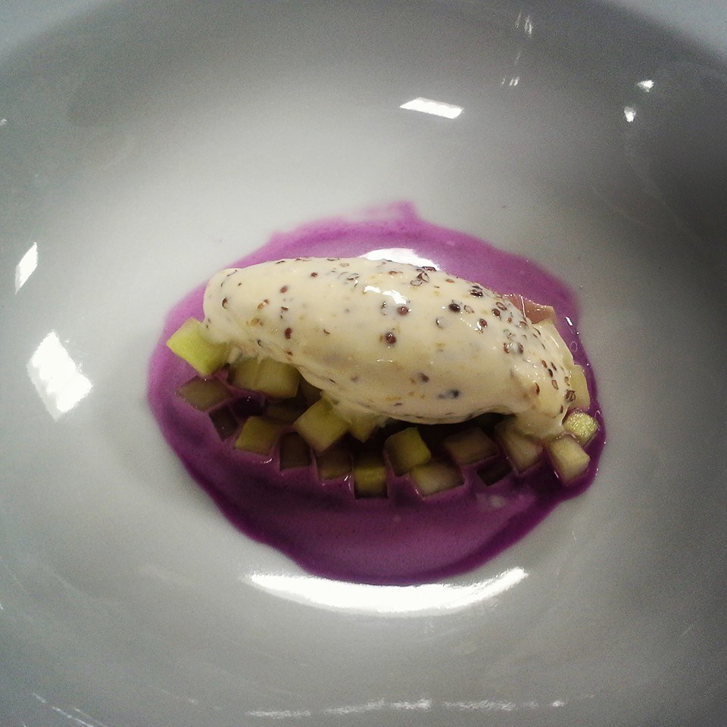

INGREDIENTS | Quantity for 4
Large egg yolk | 1
Dijon Mustard | 10g
Groundnut or Rapeseed Oil | 90g
Red wine vinegar | 10g
Red wine | 15g
FOR THE GAZPACHO
Red Cabbage | 1
1 slice bread (crust removed ) | 1
Red wine mayonnaise | 20g
Red wine vinegar | 30g
Salt
TO FINISH AND SERVE
Cucumber ¼ , peeled deseeded and finely chopped | 4scoops of mustard ice cream

PRODUCTION METHOD

MISE EN PLACE
- Gather all ingredients
- Weigh out ingredients
- Wash , peel and rewash vegetables
- Juice ¾ cabbage
- Place cabbage juice and bread in a container , refrigerate for two hours
- Make red wine mayonnaise
COOKING / PREPARATION
- For the red wine mayonnaise , combine the egg yolk with the mustard in a bowl , slowly whisk in the oil to form a emulsion
- When the emulsion is very stiff , stir in the vinegar until thoroughly combined , cover and keep in fridge until ready to use
- Strain cabbage juice through fine sieve lined with muslin cloth, (the bread releases starch into the juice, which will thicken a little). Discard the bread.
- Just before serving, juice remaining ¼ of red cabbage and strain into the rest of cabbage juice. Using a hand blender, mix the juice and mayonnaise, season with vinegar and salt.

PRESENTATION AND SERVICE
When ready to serve, put a small amount of diced cucumber at the bottom of each bowl, then place a small scoop of mustard ice cream on top. Pour the Gazpacho around the ice cream at the table.

Dish Name: Mustard Ice cream serves 3-6
Photographs of completed dish presentation
INGREDIENTS | QUANTITY FOR 3-6
Whole milk | 360g
Caster sugar | 140g
Whipping cream | 840g
Semi skimmed milk powder | 35g
Wholegrain Mustard | 120g
English Mustard | 10g

PRODUCTION METHOD
MISE EN PLACE
- Prepare ice bath
- Turn ice cream machine on at least 20 minutes before use
Cooking / preparation
- Place the milk, sugar, whipping cream and milk powder in a saucepan over medium heat and whisk until the milk powder has completely dissolved.
- Remove from heat and place container in a bowl of ice water to cool
- Once cold add two types of mustard and whisk well to incorporate.
- Pour the base into the ice cream machine with the paddle turning until ice cream is made
- Using a hand blender, blitz the ice cream for 10 seconds, replace mixing bowl in machine and churn for further 10 minutes.
SERVICE
- Decant the ice cream into a sealable container and place in the freezer for at least 2 hours before serving.

RECIPE COSTING SHEET

Dish name: Red Cabbage Gazpacho and mustard ice cream serves 4

INGREDIENT | PURCHASE  UNIT | PURCHASE UNIT COST | QUANTITY FOR 4 PORTIONS | COST  FOR 4 PORTIONS
Large egg yolk | mls | 0.29 | 1 | 0.29
Dijon Mustard | g | 0.04 | 10g | 0.04
Groundnut or Rapeseed Oil | mls | 1.95 | 90mls | 0.59
Red wine vinegar | mls | 0.06 | 20mls | 0.06
Red wine | mls | 4.57 | 15mls | 0.14
FOR THE GAZPACHO
Red Cabbage | 1 each | 1.00 | 1 | 1.00
1 slice bread (crust removed ) | 1 each | 0.25 | 1 | 0.25
Red wine vinegar | mls | 0.06 | 20mls | 0.06
Salt |  |  |  | 0.05
cucumber | each | .40 | .5 | 0.40
MUSTARD ICE CREAM
Whole milk | mls | 0.64 | 360mls | .46
Caster sugar | g | 0.25 | 150g | 0.25
Whipping cream | mls | 2.88 | 840g | 2.88
Semi skimmed milk powder | g | .07 | 25g | 0.07
Wholegrain Mustard | g | .17 | 120g | .34
English Mustard | g | .02 | 10g | 0.02
 | X | FOOD COST  MISCELLANEOUS COSTS  TOTAL COST |  | 6.88
 | X |  |  | 2.00
 | X |  |  | 8.90

COST PER 4 PORTIONS = €8.09

COST PER PORTION = 2.25

Comments/Recommendations/Action
While there are technical elements in this dish I feel you could charge at least €8.00 for this dish which will give you 72% gross profit

Calculate the Selling Price at the following GP percentages:

€5.00 @ 55%

€7.00@ 68%

€8.00 @ 72%

